Light a candle

Sign of the cross
In the name of the Father and of the Son and of the Holy Spirit. Amen.

Sing
Hymn All Together 615 “In Christ Alone” or Hymn 851 “Amazing Grace” Rend Collective “Every Giant will Fall” https://youtu.be/PXLMw13adQ8

God’s Word
Read: “The Anointing at Bethany” - Matthew 26:6-13; Mark 14: 1-9; John 12:1-8
This is the word of the Lord. Thanks be to God.

Reflection
Mary of Bethany, the sister of Martha and Lazarus, is an example for us of a faithful follower of Jesus Christ. Mary sat at Jesus’ feet eager for spiritual truth and understanding. She responded to God’s gracious love through her acts of hearing God’s Word and worshipping God through anointing her King with costly oil. Mary’s love for her Lord is self-sacrificing as she humbly anoints Jesus with oil worth about one year’s wages. Mary’s wisdom, love of God and faithful preparation is commended by Jesus.

Activity (optional)
Watch a part of the Easter story on film.

Music – ideas:
“He was despised and rejected of men” Handel
https://youtu.be/H5-yTzY1dn4
“Nearer My God to Thee” Andre Rieu - https://youtu.be/v1mQT1u_45I
Hymn 330 “Rock of Ages, cleft for me.” https://youtu.be/ZmboVILc4rw

Bible verses
Isaiah 52:13-53:12 “The Sin-Bearing Servant”
Isaiah 61:1-3 “The Good News of Salvation”

Catechism
The Third Commandment. Remember God’s special day and keep it holy.

Prayer
Lord God, our Father, help us to honour, love and trust you so that we hear your holy word and learn it gladly. Thank you for calling us and speaking to us through your word. We confess that we have not always listened to your voice and have been distracted by things of this world. We are sorry and pray for your forgiveness. Help us to know the voice of our Shepherd and to come to him when he calls. Help us to cling to the foot of the cross of our Saviour Jesus Christ. In Jesus’ name we pray. Amen.

Blessing
May the peace of God, which passes all understanding, keep our hearts and minds safe in Christ Jesus. Amen.
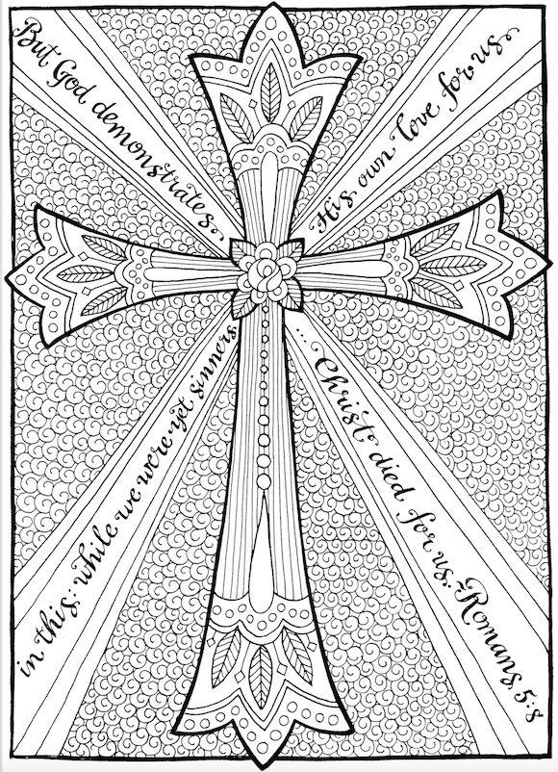 https://www.flandersfamily.info/web/2016/03/13/free-coloring-page-the-cross-of-christ/

