Light a candle

Sign of the cross
In the name of the Father and of the Son and of the Holy Spirit. Amen.

Sing
“Rescuer (Good News)” – Rend Collective https://youtu.be/leh-4fCc5MI
“Holy, Holy, Holy” - Audrey Assad https://youtu.be/AgHrNNM23p8
“Oceans (Where Feet May Fail)” – Hillsong https://youtu.be/dy9nwe9_xzw

God’s Word
Read: John 17
This is the word of the Lord. Thanks be to God.

Reflection
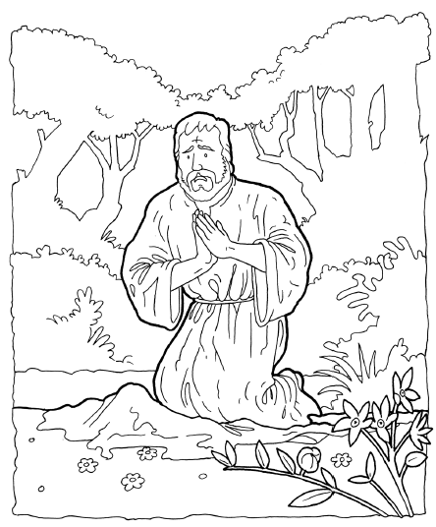
In Jesus’ beautiful prayer he asks not that his people be taken out of the world, but that God would protect us from evil in the world as we go about the work that God has prepared for us. Jesus has claimed us as his own people and has sent us into the world to share the good news of his love for all people and his victory over sin and death. The Christian life in this world is a calling to faith and acts of faith that include prayer, worship, and meditation on the word of God so that we can be fed with the Bread of Life and strengthened to serve. The Christian life is a calling to love God and the people around us in our homes and communities – to be the salt in the world. The Christian life is a calling to hope in the promises of God and to be a bringer of hope to other people – to reflect Jesus’ light in world. It is in God’s strength that we can help to bear the burdens of those in need, share our blessings with others, and tell people about the Way to eternal life.

Activity
How do we remember to pray?
Pray straightaway when the Holy Spirit prompts you – it could even be through an event or something someone says. Establish a routine that includes places and times to pray. Write down prayers or people/things to pray for – some people keep these in a book or journal. You could keep a list or schedule of different people or aspects of life to pray for.

https://www.freechristianillustrations.com/Jesus%206.pdf

Music
Sing/Listen to music. Ideas:
“Every Giant Will Fall” – Rend Collective https://youtu.be/EF84v-oOhp0
“Rescuer (Good News)” – Rend Collective https://youtu.be/sAg7rn7fH3Q
“Nobody” – Casting Crowns https://youtu.be/1yBzIt_z8oY
“Holy, Holy, Holy Lord God Almighty” https://youtu.be/UWndDW_271g
“Blessed Assurance” – Good Hope Lutheran Church choir https://youtu.be/HKNNYp3zGDY
“Bread of Heaven” - Welsh Male Voice Choir https://youtu.be/U1fLiDjLf5c

Bible verse
1 John 2:24-29

Catechism
The Tenth Commandment – Do not want anyone else’s husband or wife, servants, animals, or possessions.

Prayer
Lord God, you teach us to respect other people and relationships. You teach us to care for what we have been given and not to be envious or greedy. Thank you for teaching us what is right and wrong and for helping us to grow in wisdom. We confess that we are distracted by the treasures of this world and that we try to find security in people and things rather than trusting in you alone. Lord, help us to turn to you first in times of need and to be thankful to you for all the good things in our lives. Watch over our hearts and minds and protect us from evil, for we know that you love us and will not let anything snatch us out of your hands. In Jesus’ name we pray. Amen.

Blessing
The grace of the Lord Jesus Christ, and the love of God, and the fellowship of the Holy Spirit, be with us all. Amen.

